**Question 1**

Suppose that the government has decided to place a $1 per litre tax on soft drinks.

A. Using a supply-and-demand graph, illustrate the market for soft drinks without the tax. Label the equilibrium price and quantity and the consumer and producer surplus.

B. Now, illustrate the equilibrium in the market with the tax. Highlight the effect of the tax on the equilibrium quantity as well as consumer and producer surplus. In this market, how is the tax burden split between consumers and producers? (Economists refer to this as the “incidence” of the tax.)

C. Repeat your analysis for the case in which demand is less elastic than in your previous graphs. How are the tax incidence and changes in the equilibrium quantity and economic surplus different in this case?

**Answer:**

****A.****

[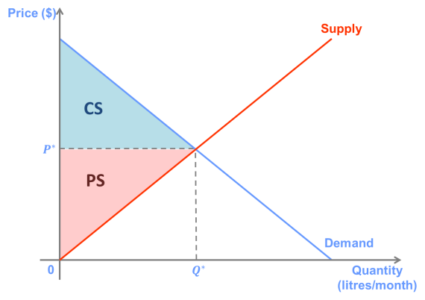](http://lionsheartstudios-publishing.com/unsw/wp-content/uploads/sites/17/2016/03/Ch5_Q1_Ans_A.png)

****B.****

[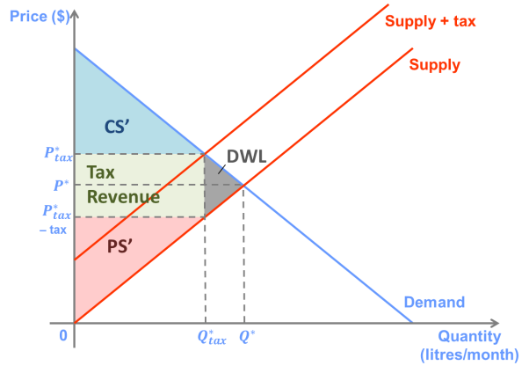](http://lionsheartstudios-publishing.com/unsw/wp-content/uploads/sites/17/2016/03/Ch5_Q1_Ans_B.png)

With the tax, the equilibrium quantity falls from *Q\** to *Q*tax*. Consumer surplus decreases from CS to CS’, and producer surplus decreases from PS to PS’. Some of this lost surplus is made up of government revenue, and the rest is deadweight loss, or surplus that disappears as a result of the tax.

As it is drawn, the incidence of the tax on consumers is roughly equal to that on consumers. On the graph, consumers’ incidence is the distance (*P*tax*– *P\**), and producers’ incidence is [*P\** – (*P*tax* – *tax*)] = *tax* – (*P*tax* – *P\**).

****C.****

[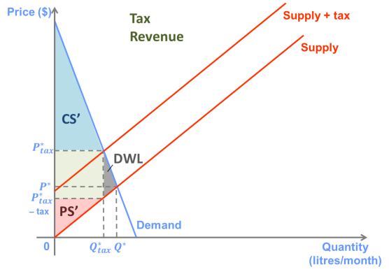](http://lionsheartstudios-publishing.com/unsw/wp-content/uploads/sites/17/2016/03/Ch5_Q1_Ans_C.png)

When demand is less elastic, then incidence of the tax falls more heavily on the buyers. The change in quantity and deadweight loss created by the tax are both smaller.

**Question 2**

Suppose that the annual market demand for cars in New South Wales is given by

P = 80,000 – Q,

and the supply is given by

P = 20,000 + 0.5Q.

A. On a graph, show the market equilibrium price and quantity.

B. Suppose that the government imposes $15,000 per car stamp duty (tax), paid by sellers. Show the new equilibrium price and quantity on your graph. Who bears the greater incidence of the tax, buyers or sellers?

C. Calculate the government revenue and deadweight loss associated with the tax.

**Answer:**

1. P=80000-Q=20000+0.5Q Q=40000,P=40000

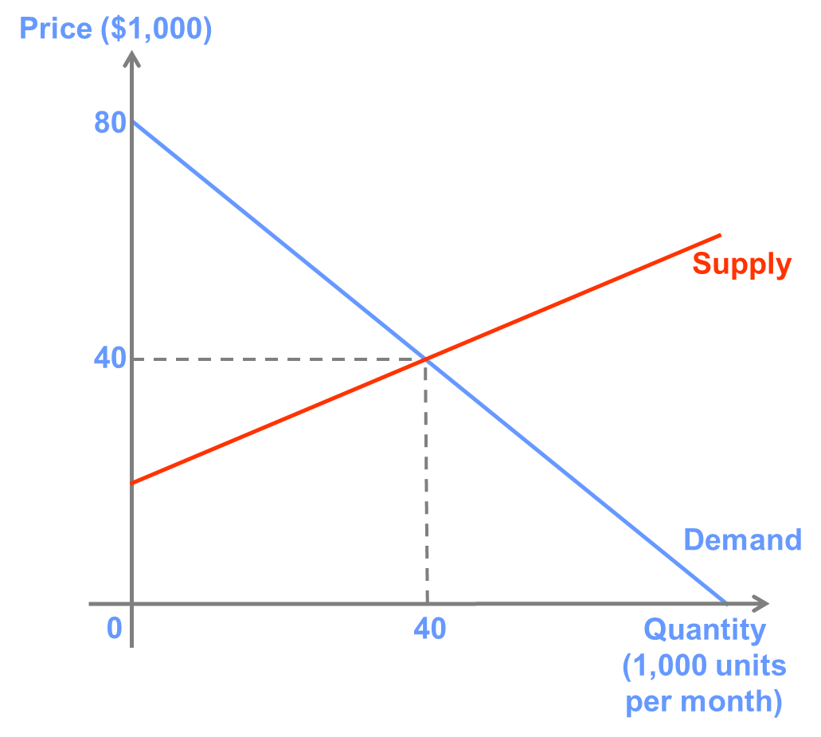

1. buyers bear the greater incidence of the tax

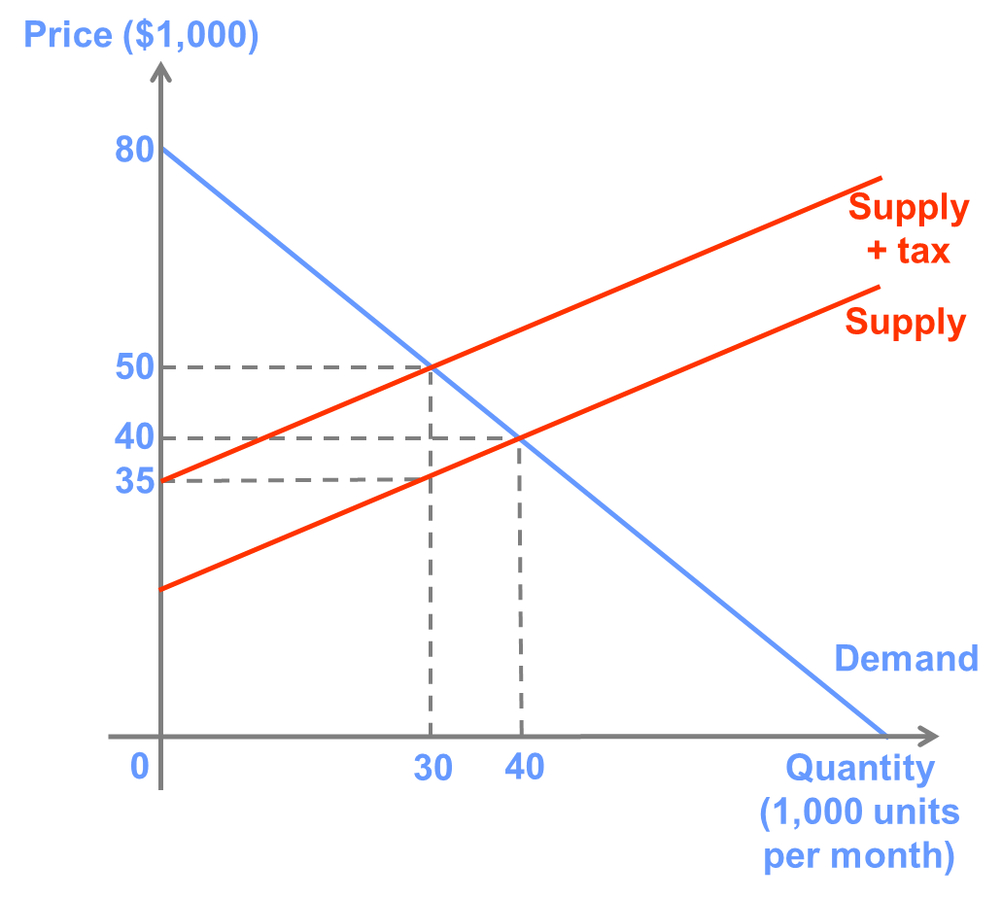

1. Government revenue=15,000*30,000=450,000,000

Deadweight loss=1/2*15,000*10,000=75,000,000

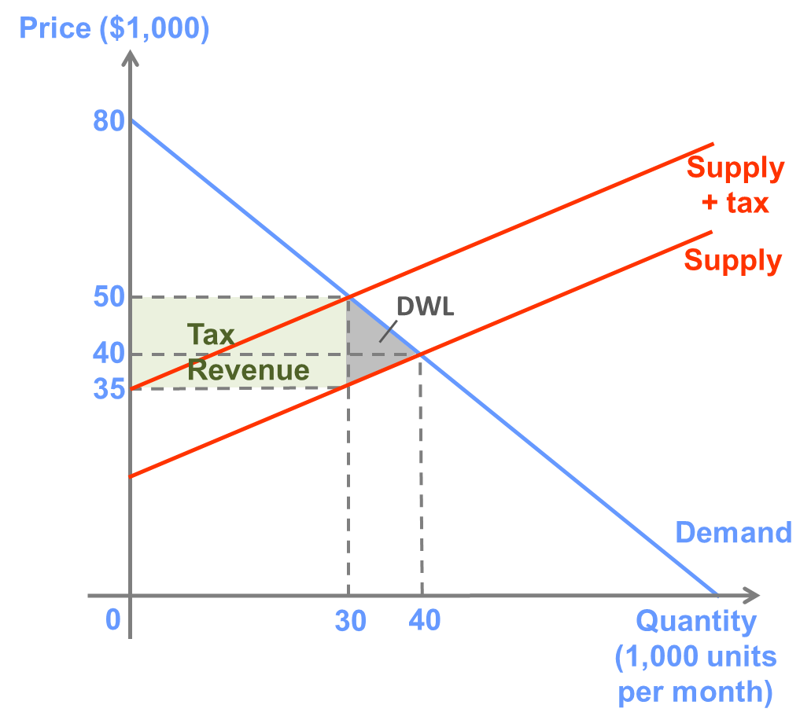

**Question 3**

Suppose that weekly demand for loaves of bread (in thousands) is given by

P = 10 – Q,

and supply is given by

P = 0.25Q.

A. On a graph, show the market equilibrium price and quantity.

B. Calculate producer and consumer surplus at the market equilibrium.

C. Suppose that the government believes that the price is too high and decides to impose a price ceiling of $1. Demonstrate the new equilibrium quantity on your graph.

D. Calculate the new producer and consumer surplus at the ceiling price.

**Answer:**

1. P=10-Q=0.25Q Q=8,P=2

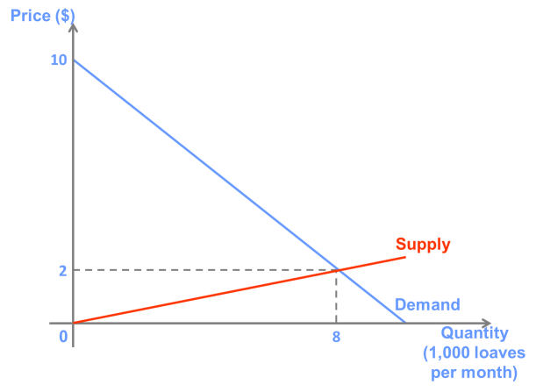

1. Producer surplus=1/2*8,000*2=8,000

Consumer surplus=1/2*8,000*8=32,000

1. 4,000

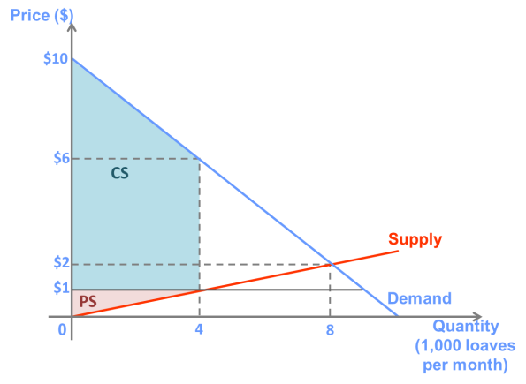

1. Producer surplus=1/2*4*1,000=2,000

Consumer surplus=1/2*4*(9,000+5,000)=28,000

**Question 4**

Suppose that the government decides that the price of milk is too low for dairy farmers to earn a comfortable living. As a result, they impose a price floor that is above the current market price.

A. Using a supply-and-demand graph, illustrate how this policy will affect the equilibrium quantity and consumer and producer surplus in the market.

B. Do you think that total revenue for dairy farmers will increase or decrease as a result of the price floor? Explain.

**Answer:**

#### A.

[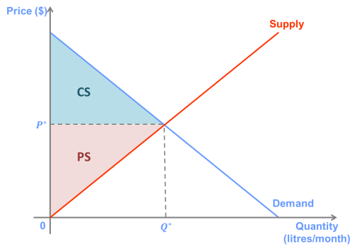](http://lionsheartstudios-publishing.com/unsw/wp-content/uploads/sites/17/2016/03/Ch5_Q4_Ans_A1.png)  [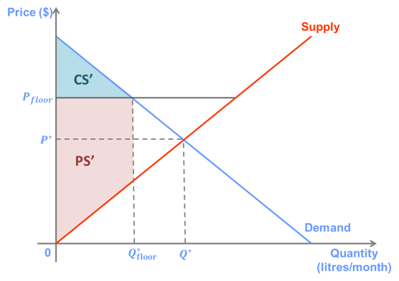](http://lionsheartstudios-publishing.com/unsw/wp-content/uploads/sites/17/2016/03/Ch5_Q4_Ans_A2.png)

The price floor reduces the equilibrium quantity from *Q\** to *Q*floor*, and reduces consumer surplus from CS to CS’.

#### B.

The change in total revenue depends on the price elasticity of demand. If demand is elastic, total revenue will fall, and if price if inelastic total revenue will rise. Demand for milk is likely to be fairly inelastic because it has few close substitutes and because it makes up a small share of most household’s purchases. Thus, revenue for farmers will likely increase as a result of the price floor.

**Question 5**

Using a supply-and-demand graph, explain why the equilibrium of a competitive market with a binding price ceiling is not Pareto efficient.

**Answer:**

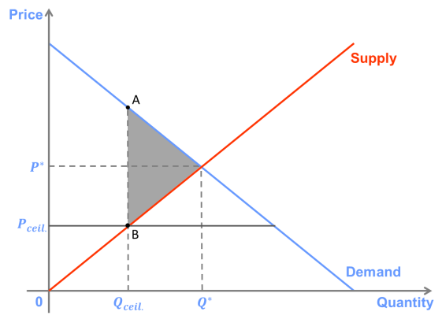

The primary effect of a price ceiling is that, because the price is held below the market equilibrium price, producers with a marginal cost above the price ceiling will not be willing to produce the good, so quantity supplied will decrease. Because there is excess demand, the goods that are produced must be rationed in some way. In a best-case scenario, those who value them the most will get them.

At this point, the marginal cost of producing one additional unit is equal to Pceil, and there is a consumer (represented by point A on the demand curve) who has a reservation greater than Pceil. If this good were to be produced and sold to this consumer for a price above Pceil, both the producer and consumer would benefit, and no one would be harmed. As a result, the equilibrium with the price ceiling is not Pareto efficient.

**Question 6**

The most prominent example of a price floor in industrialised market economies is a minimum (or award) wage.

A. Demonstrate how a minimum wage is likely to affect the total number of workers employed and the unemployment rate.

B. Are all workers made better off by an increase in the minimum wage? Explain.

C. What is the key determinant of the magnitude of the cost of an increase in the minimum wage?

**Answer:**

****A.****

[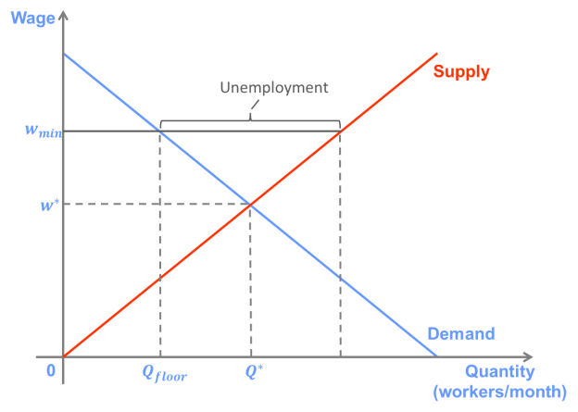](http://lionsheartstudios-publishing.com/unsw/wp-content/uploads/sites/17/2016/03/Ch5_Q6_Ans_A.png)

The figure represents the labour market. Labour is demanded by firms and supplied by individuals. The “price” of labour is the wage. In the graph, the minimum wage (a price floor) is above the equilibrium wage. As with all price floors, this results in a smaller equilibrium quantity, due to the reduced quantity demanded. It also causes and excess supply.

“Unemployment” is defined as the number of workers who would like a job but cannot find one, which in this case is the same thing as the excess supply of labour. Thus, a minimum wage increases unemployment both by reducing the number of workers demanded by firms and by increasing the number of individuals who want to work.

****B.****

Clearly, some workers are made better off because their wage increases from *w\** to *wmin*. However, the workers who now cannot get a job are clearly worse off.

One could  also argue that individuals who did not want to work at the equilibrium wage but do want to work at the minimum wage and are unable to find a job are worse off because they spend time searching for a job that they could have used for other activities.

****C.****

The primary cost is the reduction in the quantity of workers demanded, which leads to fewer workers getting jobs. The magnitude of this reduction depends on the price elasticity of labour demand. If labour demand is very inelastic, then the costs of the minimum wage will be fairly minor.

Another cost is “misallocation” of jobs if workers who have a higher marginal cost of working (and did not want to work at the equilibrium wage) displace those who have a lower marginal cost of working (and would be willing to work at the equilibrium wage). The magnitude of this cost depends on the elasticity of labour supply. If labour supply is quite inelastic, then few new workers will enter the labour force due to the higher minimum wage, and the costs of them displacing other workers will be relatively small.